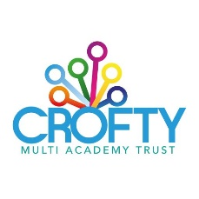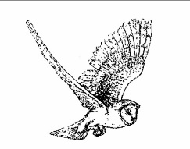
GARRAS PRIMARY SCHOOL
After school club leader – Job Vacancy
Start Date: as soon as possible.
Scale: Scale 2 (dependent on experience)
Contract: 10 hours per week over 38 working weeks [Term Time only].
As part of Crofty Multi Academy Trust, Garras Primary School is looking to appoint an after-school club lead to run a new after school provision from 3.15 – 5.15pm, Monday to Friday. Day to day responsibilities would include delivering a fun, play based, environment for children to enjoy after a busy day in school. Activities could range from physical activities/ sports to board games and craft. You will be required to supervise the children and ensure all children are happy and engaged in activities as well as offering snack/ drinks.
This is a fixed term post, from 1st January 2024 to 31st August 2024 in the first instance, and the working pattern will be Monday to Friday – Term time only – part time (3.15pm-5.15pm) – 10 hours per week.
Please contact the Pat Nicholas, school secretary on 01326 221653 for more details of the role or how to apply. Applications to be returned to: secretary@garras.cornwall.sch.uk
Please note we do not accept CVs and only applications submitted on an application form will be considered.
Closing Date: Monday 15th April 2024 (midnight)
Interview Date: Tuesday 23rd April 2024

